Cinthia Calvo Assignment 5

A new order filling system needs to be installed as soon as possible. The table on the next page lists that project’s activities and their predecessors. Also provided is the cost information to reduce the standard activity times. (problem 7-32 in the textbook)

| **ACTIVITY** | **IMMEDIATE PREDECESSORS** | **STANDARD TIME (Days)** | **STANDARD COST** | **CRASH TIME (Days)** | **CRASH COST** |
| --- | --- | --- | --- | --- | --- |
| A | -- | 7 | $2,000 | 5 | $3,500 |
| B | A | 10 | $3,000 | 8 | $4,700 |
| C | A | 8 | $3,400 | 7 | $3,700 |
| D | C | 6 | $1,600 | 4 | $2,600 |
| E | C | 7 | $1,900 | 4 | $4,000 |
| F | D,E | 5 | $1,200 | 3 | $2,800 |
| G | B,C | 11 | $8,200 | 8 | $10,900 |
| H | F,G | 4 | $2,600 | 3 | $3,800 |

**(a) Construct a project network for this problem. Determine the EST, EFT, LST, LFT, and slack for each activity. Also determine the critical path and project completion time.**

Slack:

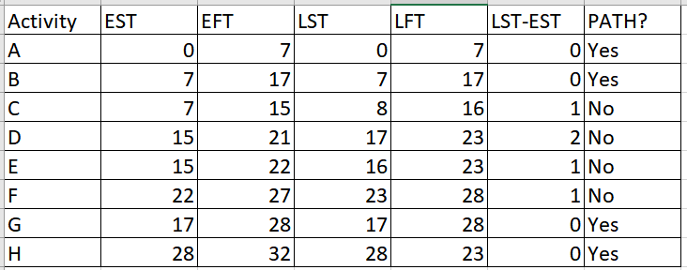

The network diagram is shown below:

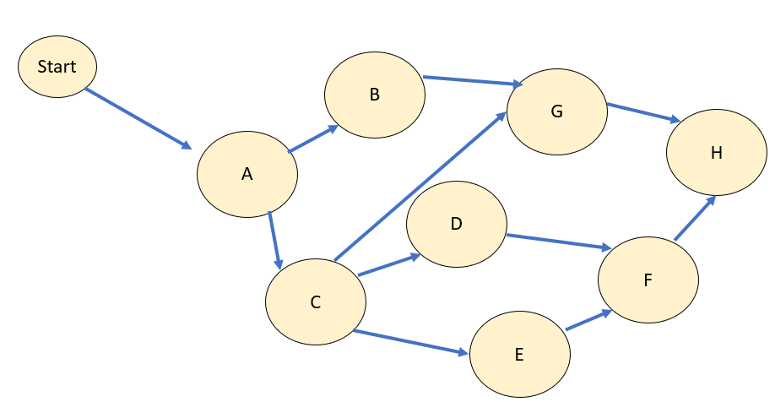

The following image shows the resulting number of paths that are accessible in the given network diagram and project completion time.

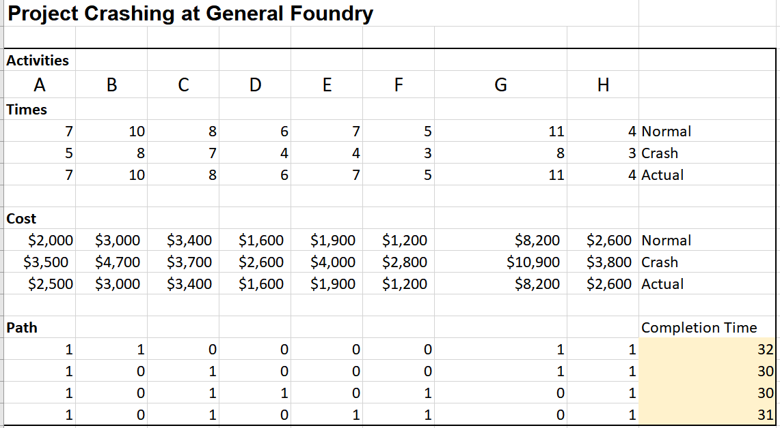

**(b)** **Set up and solve an LP model using Excel to crash this project to 24 days. What is the total crashing cost?**

The current total of the actual cost is **$23,900.** After this calculation, we use the solver parameters to calculate the final result of actual cost after the project crashing will appear.As a result, the minimum project crashed cost will be **$33,600**.

Therefore, the total crash cost is **$9,700**. (33,600 - 23,900)

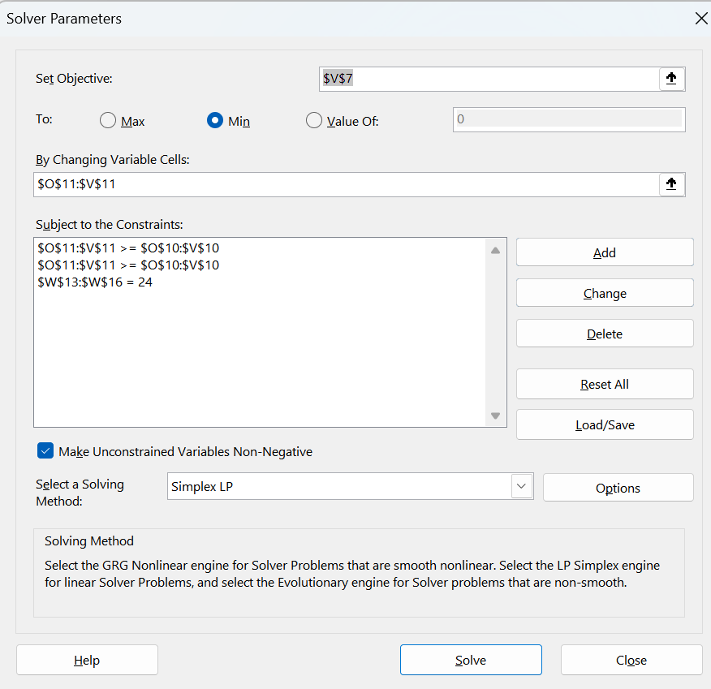

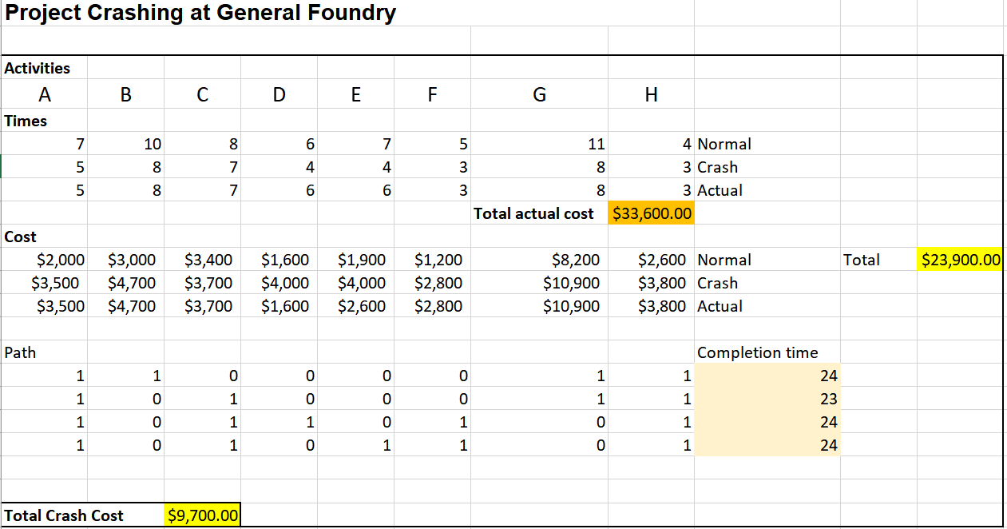

One of the most interesting discoveries this week was to be able to understand the analysis behind a crash project. The videos from the lecture were very helpful, but I also did my own research and found ways to use the solver to calculate and shows the resulting number of paths that are accessible in the given network diagram and project completion time. I felt very confident to set up the LP model to crash the project in 24 hours, the previous assignments gave me more knowledge and experience to identify the requirements used on the solver to set up the solver parameters. The purpose of the solver was to adjust the crashing levels to minimize the project duration while satisfying the constraints. This week lecture was very interesting to gain more experience into project management. This is crucial when you need to meet the tight deadline or minimize the time duration of the project. Crashing a project and using the powerful tool of Excel allows to identify critical paths that will prevent the risk associated with delays and unforeseen issues. This will ensure that resources are efficiently distributed. The only thing that remained unclear is that I’m not sure if the final result for the total crashing cost was the right answer, but hopefully I get feedback from the professor and my group.

Hi Fredis, you said very important aspects from this week's lecture. The previous assignments gave me more experience to apply my previous practice and follow the procedure with the new concepts from this week. The term of crashing a project while using the powerful tool of Excel, allows us to identify critical paths that will prevent the risk associated with delays and unforeseen issues for future projects. It also remained unclear if the result for the total crashing cost was the right answer, I feel that the calculation process needed to be clearer to understand the procedure without any doubts.